



**To Supply Leftover Food to Poor**

**Project Overview:**

**Food Connect :** The system is built to organize food donation events, manage distribution, and handle logistics by utilizing Salesforce's CRM features. It enables tracking of donors, volunteers, venues, and resources while streamlining processes like event planning, communication, and reporting. This ensures smooth coordination and efficient management of food donation and distribution activities.

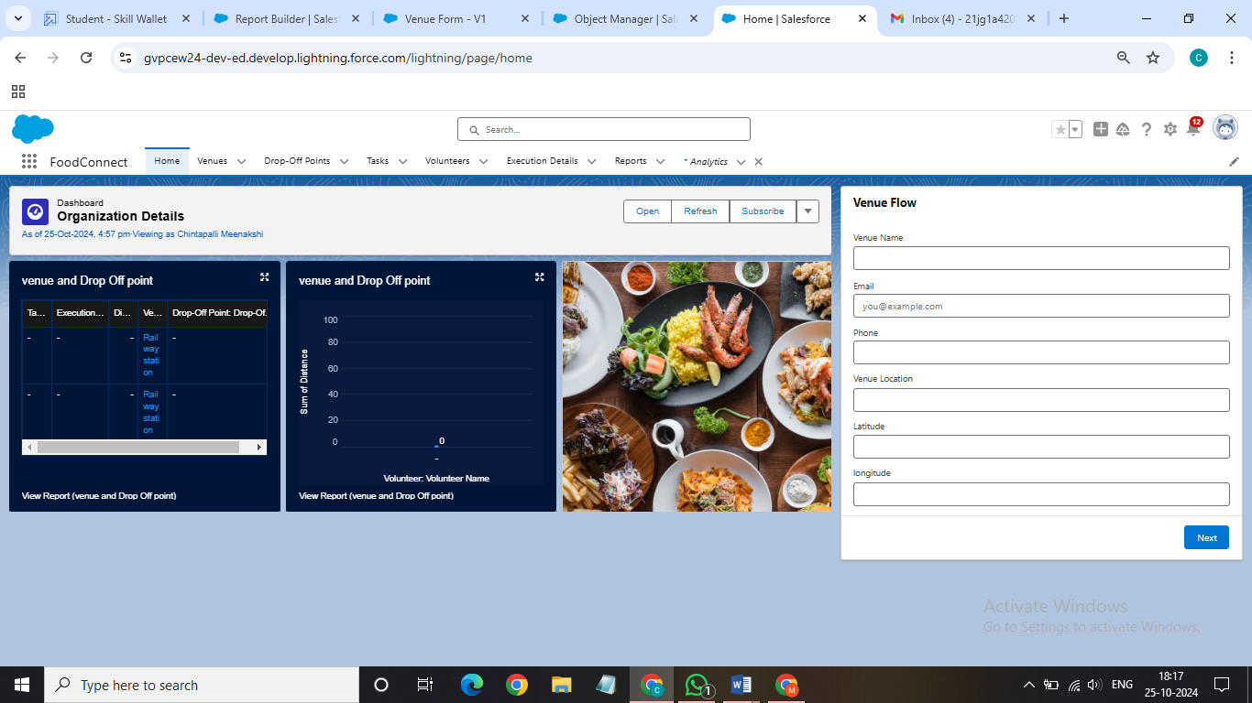

# Objectives:

**Objects :**

**Venue Object**: Manages and monitors event locations for food donation and distribution within the Food Connect initiative.

**Drop-Off Point Object**: Oversees designated sites for food donations as part of the Food Connect initiative.

**Task Object**: Tracks tasks and responsibilities associated with food donation events in the Food Connect program.

**Volunteer Object**: Manages individuals supporting food donation events and activities in Food Connect.

**Execution Details Object**: Tracks operational specifics and progress for food donation events within Food Connect.

**Tabs:**

**Venue Tab**: Gives users easy access to manage and view all Venue records, making it simple to track locations for food donation events in the Food Connect project.

**Drop-Off Point Tab**: Lets users access and manage designated food donation sites, helping with smooth collection logistics.

**Task Tab**: Shows an organized view of tasks for food donation events, helping users coordinate and assign responsibilities more effectively.

**Volunteer Tab**: Helps users manage and track volunteer involvement, ensuring volunteers are efficiently assigned to various donation activities.

**Execution Detail Tab**: Allows users to monitor and record operational details for food donation events, aiding in event execution and progress tracking.

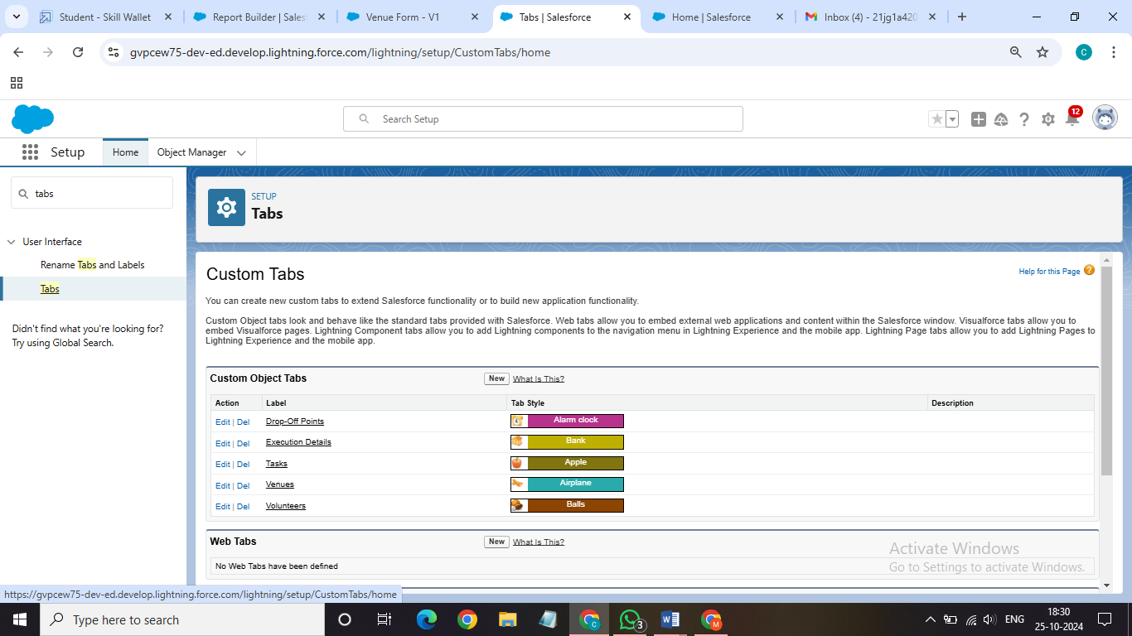

**Lightning App:**

1. App Name: FoodConnect
2. Developer Name: FoodConnect
3. Image: Optional
4. Primary Color Hex Value: Default
5. Navigation Style: Standard Navigation
6. Utility Items: Default (no custom utility items added)
7. Navigation Items:
   * Home
   * Venue
   * Drop-Off Point
   * Task
   * Volunteer
   * Execution Details
   * Reports
8. User Profile: System Administrator

# Salesforce Key Features and Concepts Utilized

**Field and Relationships:**

**Lookup Relationship (Volunteer to Drop-Off Point)**: Lets volunteers link to multiple drop-off points without strict connections.

**Master-Detail Relationship (Execution Details to Volunteer)**: Ties specific execution details to a volunteer, ensuring data integrity and automatic deletion if the volunteer record is removed.

**Master-Detail Relationship (Execution Details to Task)**: Keeps execution details dependent on a task, so they can’t exist without a related task.

**Lookup Relationship (Drop-Off Point to Venue)**: Allows drop-off points to connect with multiple venues flexibly, without strict links.

**Lookup Relationship (Task to Venue - Sponsored By)**: Lets tasks optionally link to a venue for sponsorship, without requiring the task to exist.

**Lookup Relationship (Task to Drop-Off Point)**: Allows tasks to optionally link to drop-off points, for cases where a task may not have a specific location.

# Detailed Steps to Solution Design

**Flow:**

The flow is set up to automatically create records in the Venue object, making data entry easier and improving user experience.

**Screen Flow**: This flow type lets users interact by entering data in a structured way.

**Components and Their Purpose**:

* **Screen Element (Venue Details)**: This screen allows users to enter essential details about the venue.
* **Text Component (Venue Name)**: Collects the venue name, which is important for identification.
* **Email Component (Contact Email)**: Gathers the email address of the primary contact to make communication easier.
* **Phone Component (Contact Phone)**: Collects a contact phone number to allow direct communication if needed.
* **Text Component (Venue Location)**: Lets users specify the venue's address or location, which is important for planning.
* **Number Component (Latitude)**: Collects the latitude for mapping and location purposes.
* **Number Component (Longitude)**: Collects the longitude, completing the coordinates needed to pinpoint the location.
* **Create Record Element (Create Venue Record)**: This element saves the venue details in the database to ensure all data entered is stored properly.

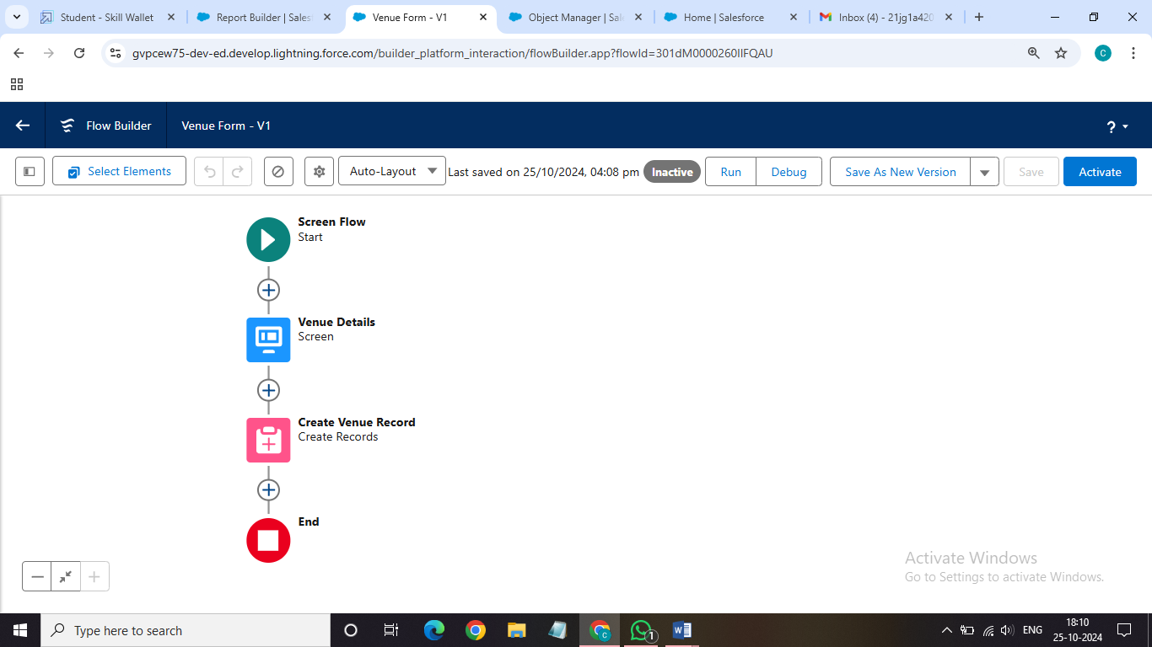

# Testing and Validation

**Trigger:**

A trigger in Salesforce enables automation and enforces business rules by performing specific actions whenever records in the Drop-Off Point object are created, updated, or deleted. This helps maintain data accuracy and improves application responsiveness based on user actions with the object.

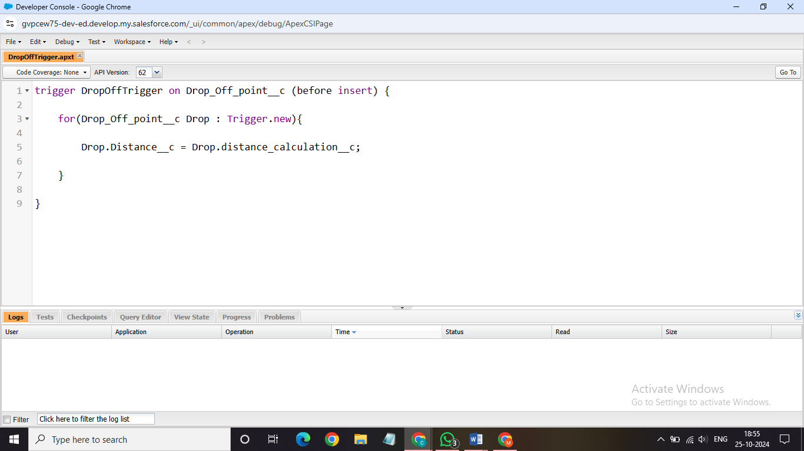

# Key Scenarios Addressed by Salesforce in the Implementation Project

**Profiles:**

To create a custom profile for specific user access and permissions**.** NGOs Profile.

Creation of User1:

* Purpose: To create a new user in Salesforce with specific details tailored for NGO use.
* User Details:
  + First Name: Iksha Foundation
  + Last Name: Iksha_Foundation
  + Alias: iiksh
  + Email: iiksh@gmail.com
  + Username: ikshafoundation@sb.com (ensure it's unique)
  + Nickname: Auto Populated
  + User License: Salesforce Platform
  + Profile: NGOs Profile
  + Active: Checked

This user will be configured to have access tailored for nonprofit operations.

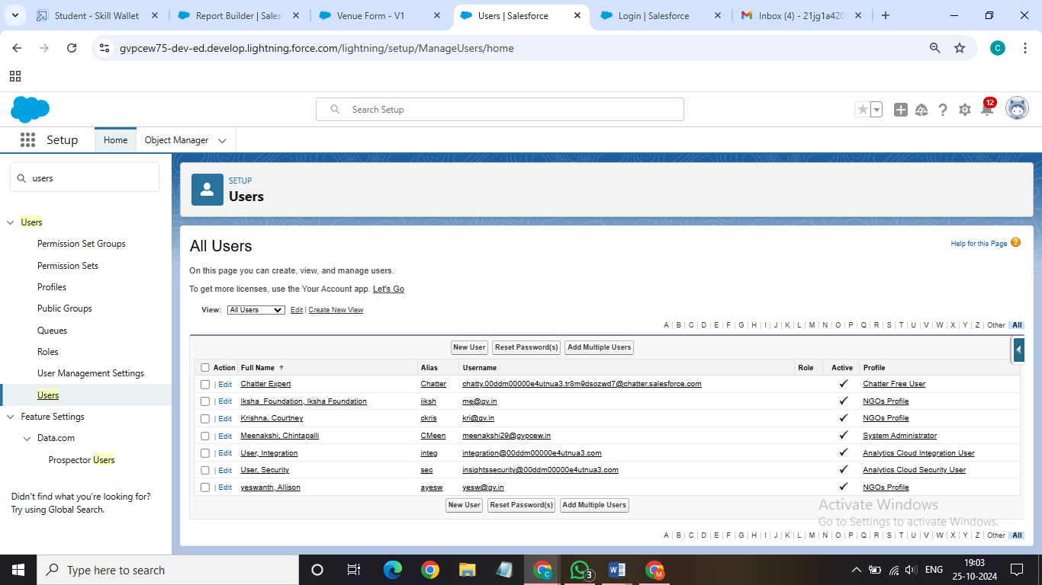

**Report Types**:

To generate custom reports that provide insights on relationships between Venues, Drop-Off Points, and Volunteers.

* Keywords:
  + Primary Object: Venues
  + Report Type Label: Venue with DropOff with Volunteer
  + Report Type Name: Venue_with_DropOff_with_Volunteer
  + Store in Category: Other Reports
  + Deployment Status: Deployed
  + Related Objects: Drop-Off Points, Volunteers
  + Relationship Option: "A" records may or may not have related "B" records

This report type helps create comprehensive reports combining data from Venues, Drop-Off Points, and Volunteers, enabling effective data analysis for nonprofit activities.

**Reports:**

Creation of Report on Venue with DropOff with Volunteer

* Purpose: To generate a custom report showing relationships between venues, drop-off points, and volunteers.
* Report Name: venue and Drop Off point
* Report Type: Venue with DropOff with Volunteer
* Group Rows by: Volunteer Name
* Columns: Venue Name, Drop-Off point Name, Distance
* Folder: Custom Reports

This report helps track and analyze volunteer activities across venues and drop-off points, facilitating operational management for nonprofits.

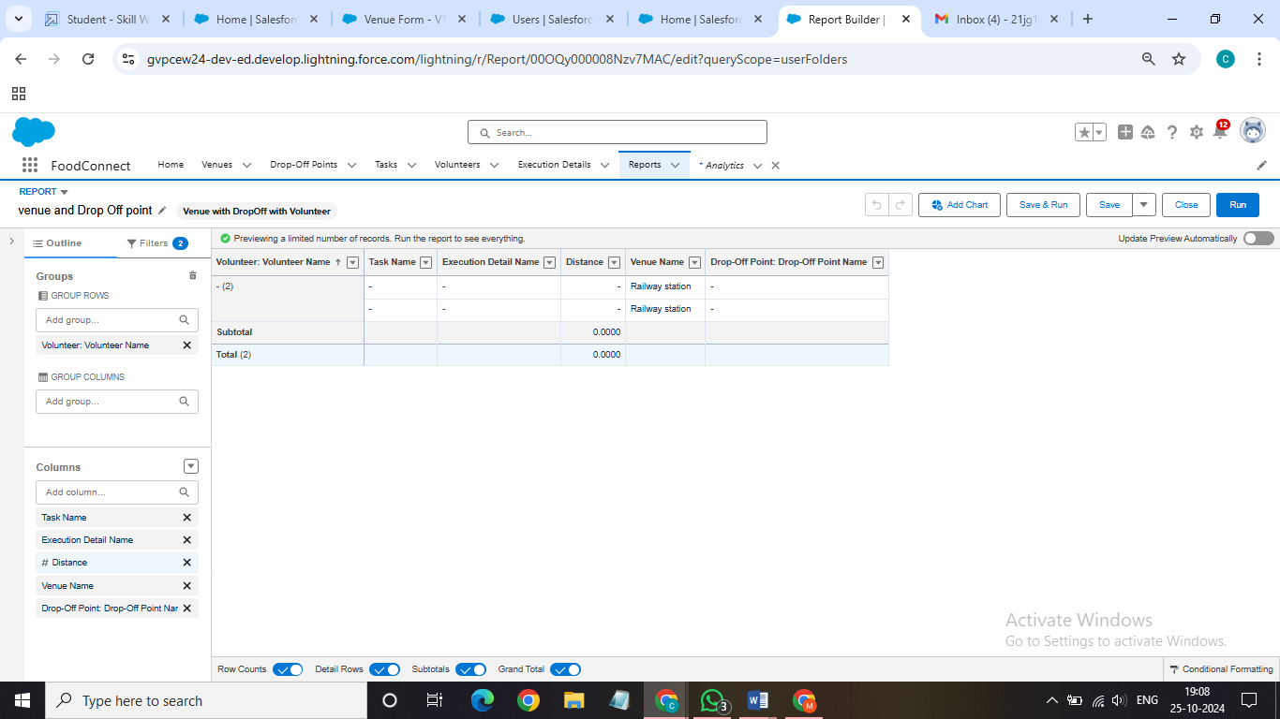

Creation of Report on Volunteers with Execution Details and Tasks

* Purpose: To generate a detailed report showing volunteer tasks, execution details, and performance ratings.
* Report Name: Volunteer Task
* Report Type: Volunteers with Execution Details and Tasks
* Group Rows by: Volunteer ID
* Columns: Volunteer Name, Task Name, Execution Detail Name, Volunteer Owner Name, Task Date, Task Rating
* Folder: Custom Reports

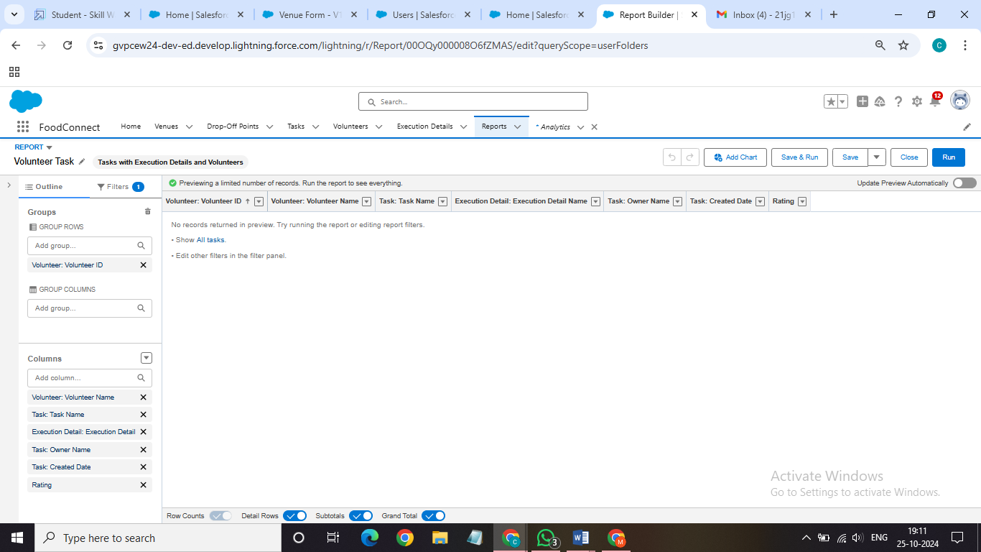

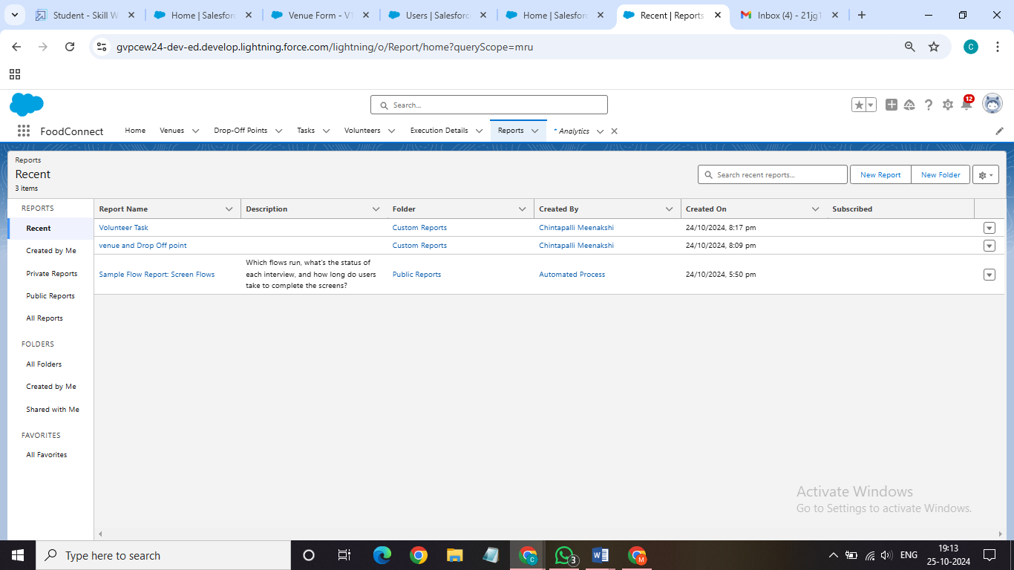

Adding venue and Drop Off point Report to the Dashboard:-

* Purpose: To visualize the "Venue and Drop Off Point" report data on a custom dashboard.
* Dashboard Name: Organization Details
* Folder: Custom Dashboards
* Report Selected: venue and Drop Off point Report
* Display As: Lightning Table
* Component Theme: Dark (Optional)

This allows real-time tracking of venue and drop-off point activities, making it easier to monitor and manage operations from the dashboard.

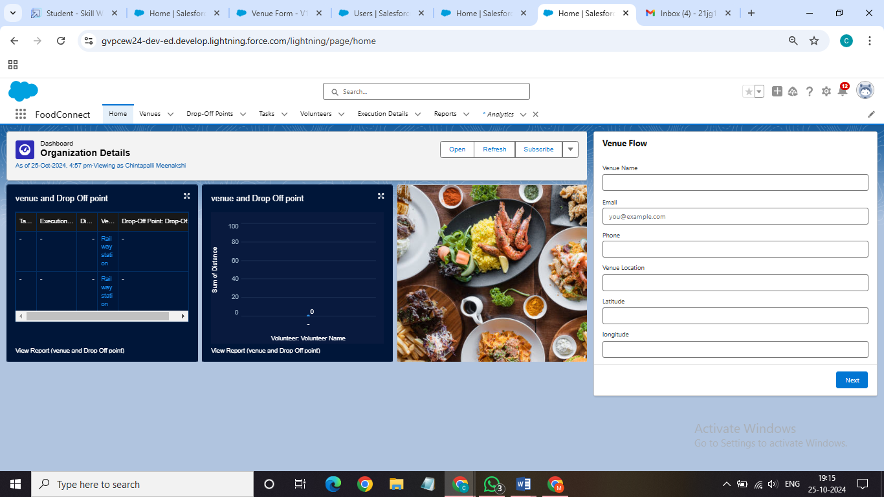

Adding "Volunteer Task" Report to the Dashboard

* Purpose: To visualize the "Volunteer Task" report on the dashboard for task tracking and performance analysis.
* Report Selected: Volunteer Task Report
* Display As: Line Chart
* Component Theme: Dark (Optional)

This setup provides a visual representation of volunteer tasks, aiding in monitoring task completion and volunteer performance efficiently on the dashboard.

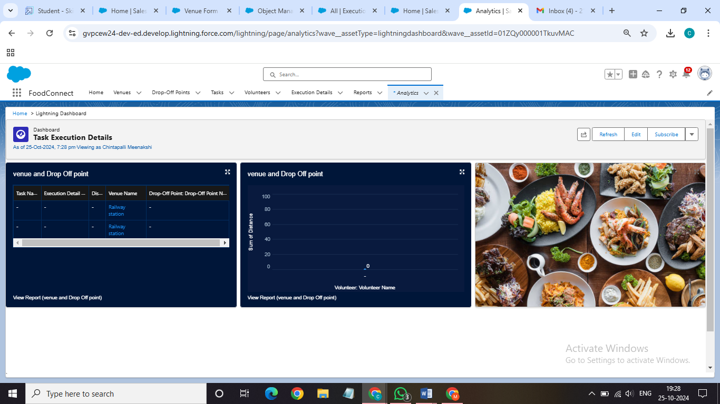

Creation of Sharing Rules

* Purpose: To control and manage access to Drop-Off point records based on distance criteria for different user groups.
* Rules:
  + Rule 1: Share Drop-Off points with a distance of less than 15 units with the "Iksha" Public Group.
  + Rule 2: Share Drop-Off points with a distance between 15 and 30 units with the "krish" Public Group.
  + Rule 3: Share Drop-Off points with a distance between 30 and 50 units with the "balaj" Public Group.

**Home Page:**

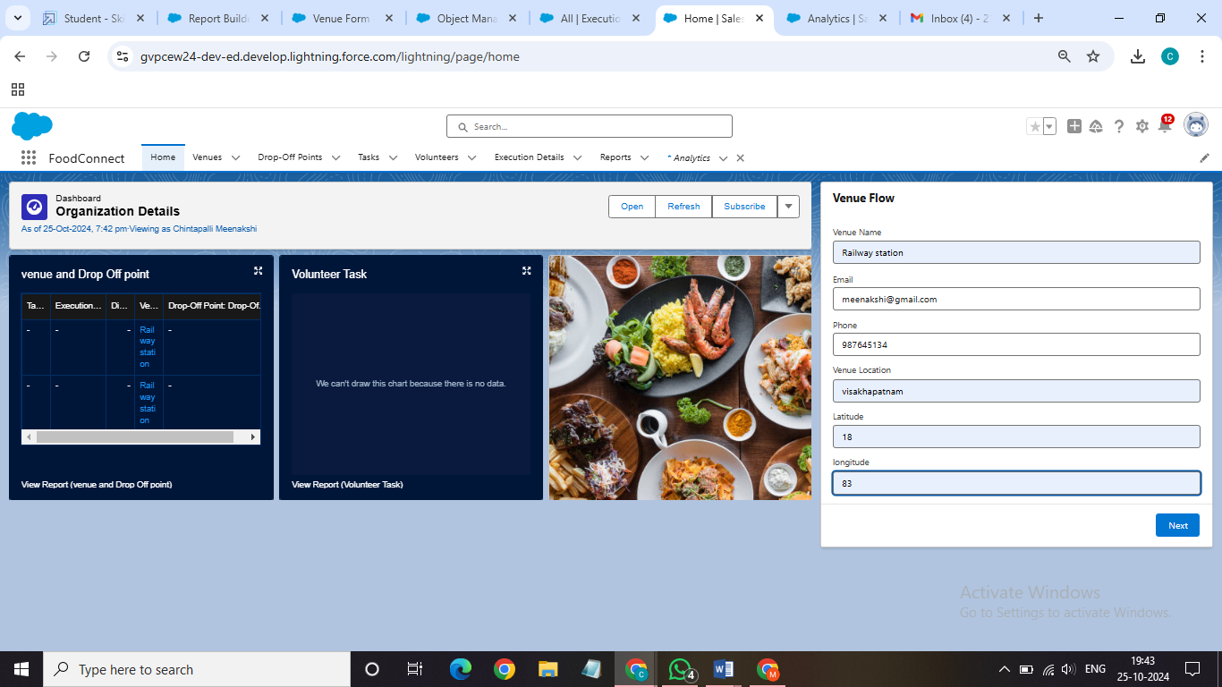

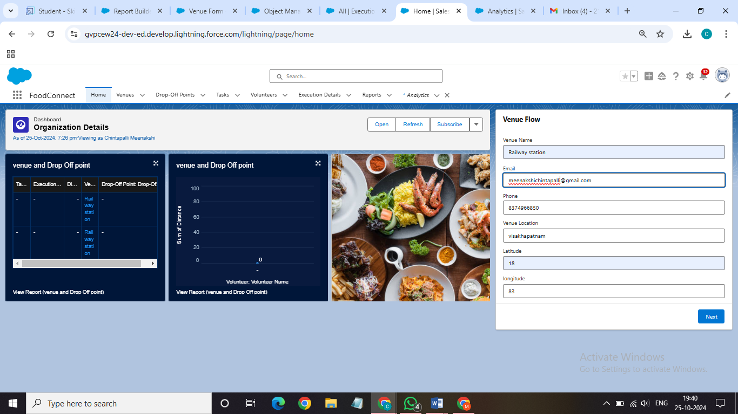

**Conclusion:**

In conclusion, developing a custom Home Page for the FoodConnect App brings together vital features such as the Venue Flow and Dashboard, offering users an organized interface to manage core functions. This tailored layout allows easy access to reports, flows, and critical organizational data, boosting both efficiency and the overall user experience in the FoodConnect application

SALESFORCE URL: [gvpcew24-dev-ed.develop.my.salesforce.com](To%20Supply%20Leftover%20Food%20to%20Poor.docx)